S.Vishnu vardhan reddy(192312244)

Experiment No:1: Simulation of FDMA in MATLAB Date

Program (Matlab Code)
clc; clear; close all; fs=1000; t=0:1/fs:1;
TBW=600; Users=3;
CBW=TBW/Users;
fc=[100 300 500]; m=sin(2*pi*10*t); s1=m.*cos(2*pi*fc(1)*t); s2=m.*cos(2*pi*fc(2)*t); s3=m.*cos(2*pi*fc(3)*t); subplot(2,1,1) plot(t,s1,'r',t,s2,'g',t,s3,'b'),grid on title('FDMA Channel Allocation'),xlabel('Time (s)'),ylabel('Amplitude') subplot(2,1,2) bar(1:Users,CBW*ones(1,Users)),grid on xlabel('Users'),ylabel('Channel Bandwidth (kHz)'),title('Channel Bandwidth per User') 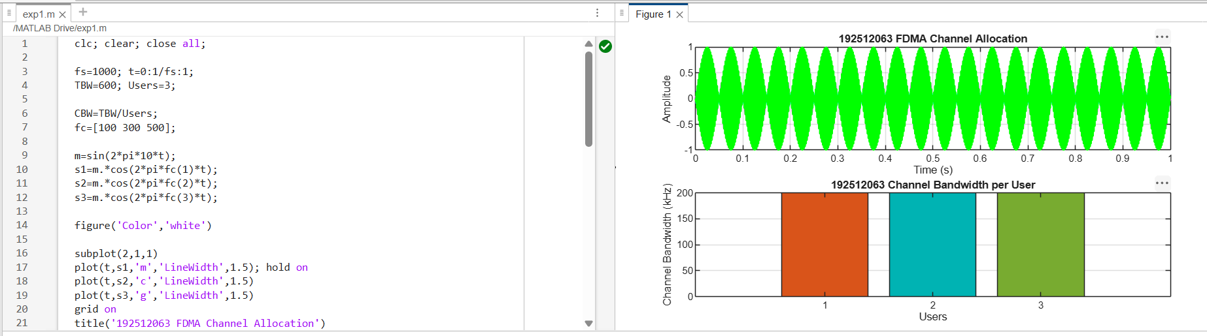
FIG.1.

Objective 2:
clc; clear; close all;
BW = 200; % Channel Bandwidth (kHz)
Users = 3;
M = 2; % BPSK Modulation
DataRate = BW*log2(M); % Data Rate (kbps) Rate = DataRate*ones(1,Users); disp(' User Data Rate (kbps)') disp([(1:Users)' Rate']) figure bar(1:Users,Rate) xlabel('Users') ylabel('Data Rate (kbps)')
title('FDMA Data Rate for Each User')
grid on
FIG.2.
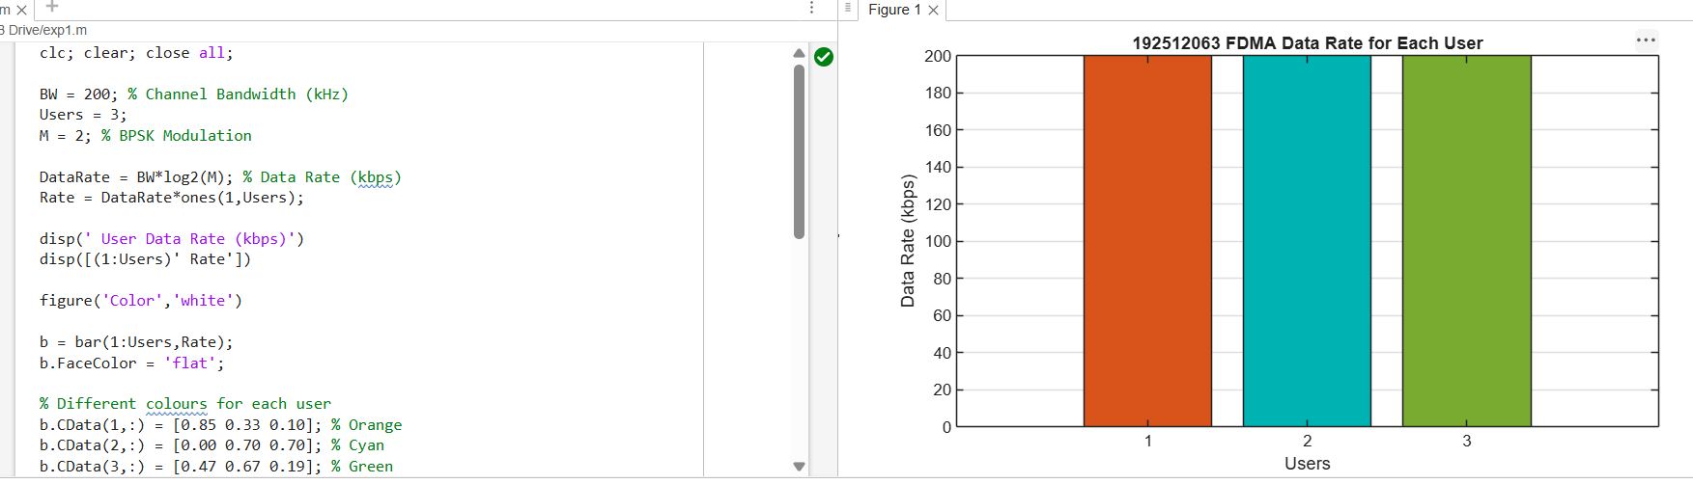

clc; clear; close all;
Ps = 1; % Signal Power (W)
Pn = [0.1 0.05 0.01]; % Noise Power (W)
Users = 1:3;
SNR = 10*log10(Ps./Pn); % SNR in dB disp('User Noise Power(W) SNR(dB)') disp([Users' Pn' SNR']) figure bar(Users,SNR) xlabel('Users') ylabel('SNR (dB)') title('Signal-to-Noise Ratio of FDMA Users') grid on
FIG.3.

